**Log Book**

14/2/19

Progress:

Game was started in Defold using Lua as coding language.

Game currently contains a simple background image (map) and sprite (placeholder)

Sprite can move up, down, left, right and has working walking animations.

Problems:

Whenever movement keys are pressed (W, A, S, D) the sprite will move while the walking animations will pause causing sprite animations to freeze while moving.

Solution was found. Added condition where key press had to be true allowing sprite to move onscreen without paused animations.

23/2/19

Progress:

Tile set and hero sprite changed.

Sprite movement now done through physics.

Player collision with the map created through kinematic (player) and static objects (walls) and collision detection.

Basic enemy behaviour created through random movements determined through random number generator.

Music capabilities implemented.

Found out how to delete game objects e.g. (enemies)

Problems:

Don’t know how to ‘attack’ the enemy and how to detect an attack from the player.

25/2/19

Progress:

Found out how to attack ‘enemies’ through the use of creating short lived objects detecting collisions when attack animation is fired.

Able to determine locations of the ‘lasers’ through use of vectors.

Problems:

Don’t know how to attack enemies besides from the one originally spawned

5/3/19

Progress:

Able to now attack enemies separately and differentiate between different enemy objects.

Problems:

Unable to treat enemy ‘health’ as separate between each entity spawned. (All enemies taking damage when hit as they are treated as the same entity).

Unable to replay enemy ‘idle’ animation after ‘damage’ animation has finished

6/3/19

Progress:

Able to spawn enemies on game load

Enemy health property now treated separately

Implemented score which is updated with every enemy defeated

Implemented player health which is updated every time damage is taken

Enemy Idle animations now play after damage animation has completed

Enemies can now attack the player

12/3/19

Progress:

Fonts and colours used for health and score display updated.

Problems:

Creating a cooldown/interval on player attack.

21/3/19

Progress:

Player now has attack cooldown set between each attack.

Problems:

Preventing player movement when in attack animation

22/3/19

Progress:

Now able to prevent player movement until attack animation completes using an interval timestamp

29/3/19

Progress:

Fixed up spawning of enemies (locations now randomly generated)

14/5/19

Progress:

Started working on boss script

16/5/19

Progress:

Added mechanic where player will speed up slightly after attacking an enemy

22/5/19

Progress:

Altered mechanic where player sped up after attacking an enemy. Player now only gains an increase of speed when the enemy is defeated. (4 seconds).

25/5/19

Progress:

Added mechanic where when player loses health, text node will appear above player noted with amount of health points lost. This was done through a label node attached to the character game object.

Problems:

Unable to recreate above mechanic with enemies.

26/5/19

Progress:

Changed mechanic used to reveal damage received in both enemies and player. Now done using factories (previously done with labels) which spawn text nodes (signifying amount of health lost) when an entity receives damage. Red text used for when player takes damage and white for enemies.

29/5/19

Progress:

Player can now trigger critical attacks where damage is doubled (Currently set to a 1 in 10 chance).

30/5/19

Progress:

Added sound effects (slime enemy hit sound, player hit sound, critical hit sound).

5/6/19

Progress:

Worked on boss script, boss now takes damage, attacks and gives score when defeated.

19/6/19

Progress:

Created Boss Fight Scenario triggered when enemy slimes reach 0

Created a GUI text node noting the current objective the player is on

26/6/19

Progress:

Added bullet mechanic where player can shoot a bullet to attack enemies

27/6/19

Progress:

Slime Boss can now move and spawns a slime each time it is attacked.

12/7/19

Progress:

Added mechanic where player can fire bullets on a 2 second countdown.

13/7/19

Progress:

New enemy types/sprites added

A level 2 stage was added

Goblin enemy chosen to be used for level 2.

14/7/19

Progress:

Goblin enemy attacking and walking animations implemented

Level 2 stage completed

Boss stage for level 2 completed

Ability for game retry implemented when game over scenario is reached

All GUI text nodes updated for level 2 stage

Fixed error in bullet interval timings being affected by timestamp used for player attacks.

17/7/19

Progress:

Errors in replaying game were fixed. (Problem where game would not restart and spawn enemies correctly.)

Fixed errors in the players and goblin boss bullet firing, where the determined bullet direction was being miscalculated.

Goblin Boss fight errors fixed

Goblin Boss fight teleporting mechanic added.

23/7/19

Progress:

Level 3 stage completed

Troll enemy used for level 3 and all enemy animations and functions implemented.

Level 3 Boss completed

Laser and sound effects added

Added text nodes that display controls to player before starting the game

**Data Dictionary -**

|  |  |  |  |  |  |  |
| --- | --- | --- | --- | --- | --- | --- |
| Data Item | Data Type | Format | Size for display | Description | Example | Validation |
| health | Integer | NNN | 1 | Amount of player health | 100 | 100 or 0 |
| Score | Integer | NNNN | 4 | Amount of score | 835 | 0 or above |
| Speed | Integer | NN | 2 | Player Speed | 55 | 55 or 65 |
| Objective Text node | String |  |  | Text node displaying current objective | “Objective: Defeat all slimes” |  |
| Coins | Integer | NN | 2 | Coin amount player has | 10 | 0 or above |
| Background Music | Audio file |  |  | Audio file for background music | Music.wav |  |
| Coin sound effect | Audio file |  |  | Audio file for coin pick up sound | ding.wav |  |
| Player hit sound effect | Audio file |  |  | Audio file for player hit | playerHit.wav |  |
| Laser sound effect | Audio File |  |  | Audio file for laser sound effect | laser.wav |  |
| Critical hit sound effect | Audio File |  |  | Audio file for critical hit sound effect | criticalHit.wav |  |
| Final Score | Integer | NNNN | 4 | Number used to determine final player score | 1820 |  |
| Hero image | Image |  |  | Image containing hero sprite | Hero.png |  |
| healthSize.x | Integer | NNN | 3 | Size value determining the length of charcter health size box | 80 | 0 or above |
| Slime Count | Integer | NN | 2 | Integer value keeping track of amount of spawned and alive ‘slime’ enemies | 6 | 0 or above |
| Slime Boss Count | Integer | N | 1 | Integer value keeping track of amount of spawned and alive ‘slimeBoss’ enemies | 1 | 0 or 1 |
| Goblin Melee Count | Integer | NN | 2 | Integer value keeping track of amount of spawned and alive ‘goblinMelee’ enemies | 9 | 0 or above |
| Goblin Melee Boss Count | Integer | N | 1 | Integer value keeping track of amount of spawned and alive ‘goblinMeleeBoss’ enemies | 1 | 0 or above |
| Troll Count | Integer | NN | 2 | Integer value keeping track of amount of spawned and alive ‘troll’ enemies | 9 | 0 or above |
| trollBossCount | integer | N | 1 | Integer value keeping track of amount of spawned and alive ‘trollBoss’ enemies | 1 | 0 or 1 |

**Algorithms**

*Character Game Object*

Set GO property “attack_interval” = 0.70

Set GO property “walk_interval” = 0.25

Set GO property “is_alive” = true

FUNCTION Init (occurs on initiation of object)

Acquire input focus

Play looping background music

scale = 1.25,1.25,1

Set game object Scale to ‘scale’

Self.vel = vmath.vector3()

self.timestamp = 0

self.fireTimestamp = 0

heroDmgAmount = 10

playerDirection = “down"

health = 0

speed = 55

score = 0

coins = 0

level2 = false

gameOver = true

ENDFUNCTION

FUNCTION update (occurs every game tick)

Get current player position

Player position = Current player position + Current Velocity * Every game tick

Set position of ‘Player’ game object

Player ‘x’ velocity = 0

Player ‘y’ velocity = 0

IF time since last bullet fire > 1.5 then

canFire = true

ELSE

canFire = false

ENDIF

IF Time since last player attack < 4 then

canTeleport = false

ELSEIF Time since last player attack > 4 then

canTeleport = true

speed = 55

ENDIF

IF health <= 0 then

canMove = false

gameOver = true

Set GO property “is_alive” = false

Set player position to (517, -320, 0.1)

Set position of ‘Player’ game object

ELSEIF health >= 0 and slimeCount > 0 and gameOver = true then

canMove = true

slimeBossEncounter = false

goblinMeleeBossEncounter = false

goblinMeleeBossRoom = false

level2 = false

gameOver = false

Set GO property “is_alive” = true

ENDIF

IF gameOver = true then

Send Message “game_final” to Interface GUI script

ELSEIF gameOver == false then

Send Message “game_current” to Interface GUI script

ENDIF

END FUNCTION

FUNCTION on_message(self, message_id, message, sender)

IF message received is “gameFinish” then

gameOver = true

canMove = false

Set player position to (-517, -320, 0.1)

Set position of ‘Player’ game object

Set GO property “is_alive” = false

Send message “game_final” to interface GUI

ENDIF

IF slimeCount = 0 and Time since last player attack > 4 and slimeBossEncounter = false then

Set player position to (110,600,0.05)

Set position of ‘Player’ game object

slimeBossEncounter = true

Send message “slimeBossEncounter” to interface GUI

ELSEIF goblinMeleeCount == 0 and level2 == true and Time since last player attack > 4 and goblinMeleeBossRoom == false then

Set player position to (1080,-400,0.05)

Set position of ‘Player’ game object

goblinMeleeBossRoom = true

FOR goblinMeleeSpawn = 1,5 do

Spawn goblin enemy in a random position within goblinBossRoom

NEXT

ELSEIF goblinMeleeBossCount == 0 and goblinMeleeBossEncounter == true and Time since last player attack > 4 then

Set player position to (1080,400,0.1)

Set position of ‘Player’ game object

health = 100

Send message “update_health” to interface GUI

goblinMeleeBossEncounter = false

ENDIF

IF message received is “spawnSlime” then

Spawn slime enemy in a random area within slimeBossRoom

ENDIF

IF Message received is “slimeBossDeath” then

FOR slimeSpawn = 1,2 do

slimeSpawn = Random area within SlimeBossRoom

Spawn Slime at ‘slimeSpawn’

NEXT

ENDIF

IF Message received is “contact_point_response” then

Set current player position to (Current player position + Direction of contact * Distance from collision)

ENDIF

IF Message received is “damageHero” or “damage” then

Send Message “play_sound” to “/hero#playerHit”

Display Text showing amount of health lost above player

health = health - slimeDmgAmount

Play animation “upDamage”

Send Message “hero_damage” to interface GUI

ENDIF

IF Message received is “speed” then

speed = 65

ELSEIF Message received is “level2” and level2 = false then

Set player position to (120, -180, 0.5)

Set position of ‘Player’ game object

level2 = true

health = 100

Send message “update_health” to interface GUI

Send message “startLevel2” to map script

ENDIF

ENDFUNCTION

FUNCTION on_input(self, action_id, action)

IF health <= 0 and message received is “restart_game” then

Set GO property “is_alive” = true

health = 100

Send message “update_health” to interface GUI

Send message “retry” to interface GUI

Send message “restart_game” to map script

Set player position to (115,275,0.1)

Set position of ‘Player’ game object

score = 0

coins = 0

Send message “update_score” to interface GUI

Send message “update_coins” to interface GUI

ENDIF

IF Input message received is "bullet" and Action key pressed down = true and canFire = true then

canFire = false

self.fireTimestamp = OS Time

IF playerDirection == "right" then

Create bullet object to the right of the player

ELSEIF playerDirection == "left" then

Create bullet object to the left of the player

ELSEIF playerDirection == "up" then

Create bullet object above the player

ELSEIF playerDirection == "down" then

Create bullet object below the player

ENDIF

ENDIF

IF OS Time > (self.timestamp + self.walk_interval) and canMove == true then

IF Input message received is "move_up" then

playerDirection = "up"

Player ‘y’ velocity = speed

IF Action key pressed down = true then

Play up walking animation

ENDIF

ELSEIF Input message received is “move_down” then

playerDirection = "down"

Player ‘y’ velocity = -speed

IF Action key pressed down = true then

Play down walking animation

ENDIF

ELSEIF Input message received is “move_right” then

playerDirection = "right"

Player ‘x’ velocity = speed

IF Action key pressed down = true then

Play right walking animation

ENDIF

ELSEIF Input message received is “move_left” then

playerDirection = "left"

Player ‘x’ velocity = -speed

IF Action key pressed down = true then

Play left walking animation

ENDIF

ENDIF

ENDIF

IF OS Time > (self.timestamp + self.attack_interval) then

IF Input message received is “attack_right” then

self.timestamp = OS Time

Play right attack animation

Create attack object to the right of the player

ELSEIF Input message received is “attack_left” then

self.timestamp = OS Time

Play left attack animation

Create attack object to the left of the player

ELSEIF Input message received is “attack_up” then

self.timestamp = socket.gettime()

Play up attack animation

Create attack object above the player

ELSEIF Input message received is “attack_down” then

self.timestamp = socket.gettime()

Play down attack animation

Create attack object below the player

ENDIF

ENDIF

*Slime Game Object*

FUNCTION init(self)

Acquire input focus

self.vel = vmath.vector3()

self.slimeHealth = 20

slimeDmgAmount = 10

slimeCount = slimeCount + 1

self.deathTimestamp = 0

ENDFUNCTION

FUNCTION final(self)

score = score + random integer between 1 and 5

Send message “update_score” to interface GUI

slimeCount = slimeCount - 1

ENDFUNCTION

FUNCTION update (self, dt)

IF GO property “is_alive” = false then

Delete GO

ENDIF

IF self.slimeHealth > 0 then

self.deathTimestamp = OS Time

ELSE

self.deathTimestamp = self.deathTimestamp

ENDIF

IF Time since death of GO is > 0.5 then

Play slime death sound

Send message “speed” to player

Spawn coin at current GO position

Delete GO

ENDIF

Get current player position

Player position = Current player position + Current player velocity * Every game tick

Set position of ‘Slime’ game object

local movement = Random integer between 1 and 500

IF movement = 1 then

Player ‘y’ velocity = 10

ELSEIF movement = 2 then

Player ‘y’ velocity = -10

ELSEIF movement = 3 then

Player ‘x’ velocity = 10

ELSEIF movement = 4 then

Player ‘x’ velocity = -10

ELSEIF movement = 20 then

Play right attack animation

Create attack object to the right of current position

ELSEIF movement = 40 then

Play left attack animation

Create attack object to the left of current position

ELSEIF movement == 60 then

Play up attack animation

Create attack object above current position

ELSEIF movement == 80 then

Play down attack animation

Create attack object below current position

ENDIF

ENDFUNCTION

FUNCTION on_message (self, message_id, message, sender)

IF Message received is “contact_point_response” then

Set current position to (Current position + Direction of contact * Distance from collision)

ENDIF

IF Message received is “damage” then

Display text node showing health lost above current position

Play upDamage animation

self.slimeHealth = self.slimeHealth - heroDmgAmount

Play slimeHit sound

ELSEIF Message received is “animation_done” then

Play idle animation

ENDIF

ENDFUNCTION

Bullet Script

FUNCTION init(self)

Scale = 0.1,0.3,1

Set GO scale to ‘Scale’

self.vel = vmath.vector3()

Play laser sound

local bulletSpeed = 250

IF playerDirection = "down" then

Bullet ‘y’ velocity = -bulletSpeed

ELSEIF playerDirection = "up" then

Bullet ‘y’ velocity = bulletSpeed

ELSEIF playerDirection =="left" then

Bullet ‘x’ velocity = -bulletSpeed

ELSEIF playerDirection = "right" then

Bullet ‘x’ velocity = bulletSpeed

ENDIF

ENDFUNCTION

FUNCTION final(self)

Play laser sound

ENDFUNCTION

FUNCTION update(self, dt)

Get current GO position

Current position = Current position + Current Velocity * Every game tick

Set position of ‘bullet’ GO

ENDFUNCTION

FUNCTION on_message(self, message_id, message, sender)

IF Message received is “contact_point_response” then

enemy = Id of other object within collision

Send message “damage” to ‘enemy’

Delete GO

ENDIF

ENDFUNCTION

Score GUI script

FUNCTION init(self)

scoreText = Text node “scoreText”

heroHealth = Text node “heroHealth”

coinsScore = Text node “coinsScore”

heroHealthBox = Box node “heroHealthBox”

objective = Text node “objective”

gameOverText = Text node “gameOverText”

controlTutorial = Text node “controlTutorial”

ENDFUNCTION

FUNCTION update(self, dt)

IF slimeBossCount == 0 and slimeCount < 1 and slimeBossEncounter == true and canTeleport == true and level2 == false then

Set objective text node to display “Objective: Defeat All Goblins"

Send message “level2” to player script

ENDIF

IF health <= 0 or gameOver == true then

Set objective text node to display “Press Enter to Start or Retry”

ENDIF

ENDFUNCTION

FUNCTION on_message(self, message_id, message, sender)

IF Message received is “game_final” then

Set gameOverText node to display “"Final Score: " .. score”

Enable text node controlTutorial

ELSEIF Message received is “game_current” then

Set text node gameOverText to display “ “

Disable text node controlTutorial

ENDIF

IF Message received is “slimeBossEncounter” then

Set objective text node to display “Objective: Defeat Slime Boss”

ELSEIF slimeCount > 1 or Message received is “retry” then

Set objective text node to display “Objective: Defeat All Slimes”

ELSEIF Message received is “goblinMeleeBossEncounter” then

Set objective text to display “Objective: Defeat Goblin Boss”

ELSEIF goblinMeleeCount > 1 then

Set objective text node to display “Objective: Defeat All Goblins”

ELSEIF trollCount > 1 and goblinMeleeBossCount == 0 then

Set objective text node to display “Objective: Defeat All Trolls”

ENDIF

IF Message received is “update_coins” then

Set scoreText node to display "Score: " .. score

ELSEIF Message received is “hero_damage” then

Get heroHealthBox size

Reduce heroHealthBox.x by 10

Set heroHealthBox size

Set heroHealth text node to display “Health: “

ELSEIF Message received is “update_health” then

Get heroHealthBox size

healthSize.x = 100

Set heroHealthBox size

Set heroHealth text node to display “Health: “

ELSEIF Message received is “update_coins” then

Set coinsScore text node to display "Coins: " .. coins

ENDIF

ENDFUNCTION

**User Manual**

How to play:

Interface –

The Health bar displays how much health the player currently and it found on the top left corner of the screen.

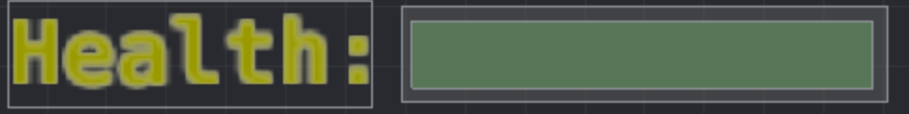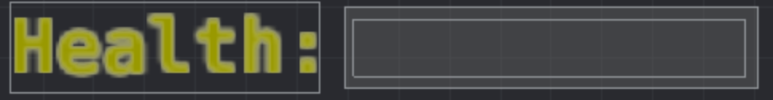

The left image shows the player on full health and the right image shows the player with 0 health. When the player reaches 0 health the game ends and the end game screen is shown.



When the game ends or before the game starts the final score text node displays the final score of the previous game or 0 if the game hasn’t been played yet.

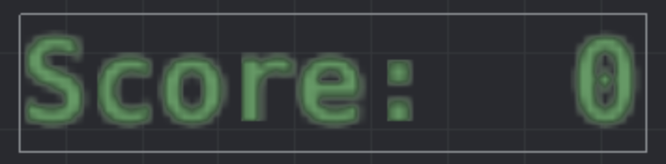

The score text node displays the players accumulative score throughout each play through of the game and is reset when the game restarts.



The objective text node displays the next objective the player has to meet to progress within the game. The objective text node is found at the top centre of the screen.

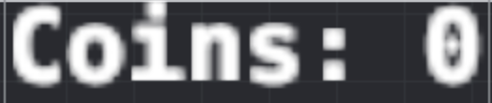

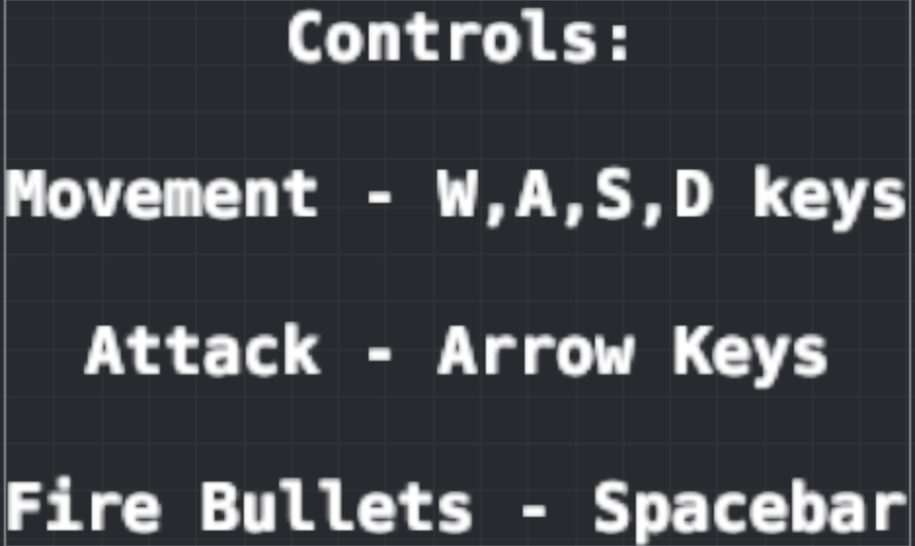The Coins text node displays the players current coin count and increases as the player picks up coins in the game. The coin amount contributes to the final calculated score and is reset to 0 when the game is restarted. The coin text node is found on the top right corner of the screen.

The controls text node shows the available actions the player can do and the respective keys to execute them. The control text node is enabled and shown at the start of the game and on the game over screen, it is disabled when the game is in play. The control text node when enabled is shown on the left side of the screen.

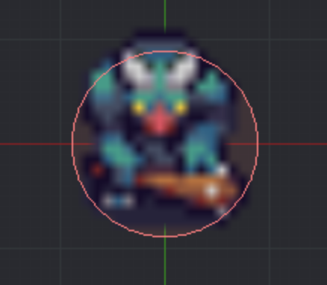Player and Enemies –

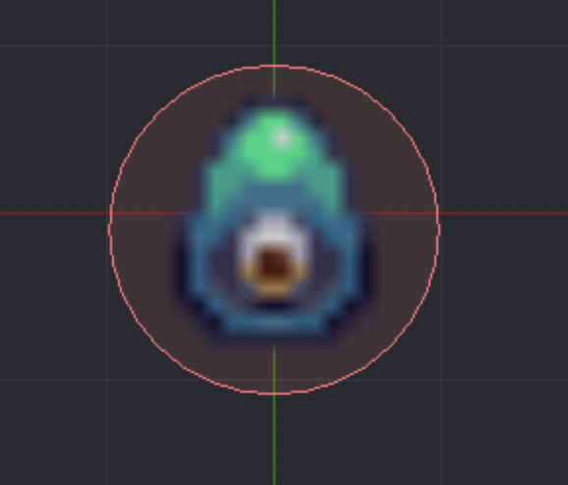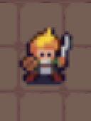

The left image shows the character sprite and the middle and right images show examples of enemy sprites throughout the game. The aim of the game is to defeat these enemies and progress through the game until the final boss is defeated and a final score is calculated.

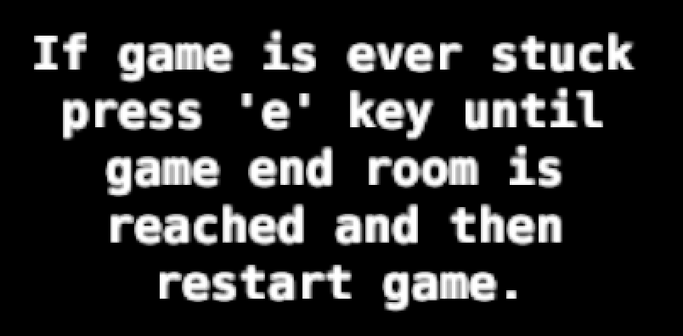

The above text node displayed before the game starts and during the game over screen, reveals instructions that the player can conduct if errors occur within the game and the player cannot progress further within the game. As seen within the image above if the player is ever stuck within the game the ‘e’ key should be pressed until the game over room is reached and then press the ‘enter’ key to restart the game. The text node is found on the right side of the screen when enabled.

**Installation Guide**

To open Mac application -

To play game once Mac application is installed/downloaded, double click application and then follow on screen instructions to play.

To install Defold –

On Mac –

The downloaded file is a DMG image containing the program.

1. Locate the file “Defold-x86_64-darwin.dmg” and double click it to open the image.

2. Drag the application “Defold” to the “Applications” folder link.

To start the editor, open your “Applications” folder and double click the file “Defold”.

On Windows –

The downloaded file is a ZIP archive that needs to be extracted:

1. Locate the archive file “Defold-x86_64-win32.zip” (or “Defold-x86-win32.zip” for 32 bit Windows), press and hold (or right-click) the folder, select *Extract All*, and then follow the instructions to extract the archive to a folder named “Defold”.

2. Move the folder “Defold” to “C:\Program Files (86x)”

To start the editor, open the folder “Defold” and double click the file “Defold.exe”

To open the project in Defold

1. Open Defold

2. Under the home tab found on the left side of the application, click on “Open from Disk…”.

3. Locate the project folder on computer and open it.

4. Once opened locate file name “game.project” and click open it.

5. Defold will then load the project file.

**Troubleshooting Guide**

|  |  |
| --- | --- |
| Problem | Fix |
| Enemy game object glitches out and leaves the room and the game cannot progress as player can no longer reach it and defeat it. | Press the ‘e’ button on the keyboard until game over room is reached and game can be reset. |
| Game does not progress even after objective has been achieved | Press the ‘e’ button on the keyboard until game over room is reached and game can be reset. |
| When in boss room and all enemies have been defeated but boss doesn’t spawn. | Press the ‘e’ button on the keyboard until game over room is reached and game can be reset. |
| If game freezes or does not load | Restart application |
| If player is stuck in the wall or has left the play zone | Press the ‘e’ button on the keyboard until game over room is reached and game can be reset. |

if slimeCount == 0 and (socket.gettime() - self.timestamp) > 4 and slimeBossEncounter == false then

p = vmath.vector3(110,600,0.05)

go.set_position(p)

slimeBossEncounter = true

msg.post("/interface#gui", "slimeBossEncounter")

elseif goblinMeleeCount == 0 and level2 == true and (socket.gettime() - self.timestamp) > 4 and goblinMeleeBossRoom == false then

p = vmath.vector3(1080,-400,0.05)

go.set_position(p)

goblinMeleeBossRoom = true

for goblinMeleeSpawn = 1,5 do

goblinMeleeSpawn = vmath.vector3(math.random(1000,1200),math.random(-420,-200), 0.5)

factory.create("/map#goblinMeleeFactory", goblinMeleeSpawn)

end

elseif goblinMeleeBossCount == 0 and goblinMeleeBossEncounter == true and (socket.gettime() - self.timestamp) > 4 then

p = vmath.vector3(1080,400,0.1)

go.set_position(p)

health = 100

msg.post("/interface#gui", "update_health")

goblinMeleeBossEncounter = false

end

**Test Data**

slimeCount == 0 , (socket.gettime() - self.timestamp) > 4 , slimeBossEncounter == false ,

**Desk Check**

|  |  |  |  |
| --- | --- | --- | --- |
| Line | p | slimeBossEncounter | Output |
| 1 | p = vmath.vector3(110,600,0.05) |  | New player position is set |
| 2 |  |  | Sets player position to new location |
| 3 |  | slimeBossEncounter = true |  |
| 4 |  |  | Sends message “slimeBossEncounter” to interface GUI script |
| 5 |  |  |  |

**Test Data 2**

goblinMeleeCount == 0 , level2 = true , (socket.gettime() - self.timestamp) > 4 , goblinMeleeBossRoom == false

**Desk Check 2**

|  |  |  |  |  |
| --- | --- | --- | --- | --- |
| Line | P | goblinMeleeBossRoom | goblinMeleeSpawn | Output |
| 1 | p = vmath.vector3(1080,-400,0.05) |  |  | New player position is set |
| 2 |  |  |  | Set player position to new location |
| 3 |  | goblinMeleeBossRoom = true |  |  |
| 4 |  |  | 1 |  |
| 5 |  |  | goblinMeleeSpawn = vmath.vector3(math.random(1000,1200),math.random(-420,-200), 0.5) |  |
| 6 |  |  |  | Spawns goblin enemy at goblinMeleeSpawn |
| 7 |  |  | 2 |  |
| 8 |  |  | goblinMeleeSpawn = vmath.vector3(math.random(1000,1200),math.random(-420,-200), 0.5) |  |
| 9 |  |  |  | Spawns goblin enemy at goblinMeleeSpawn |
| 10 |  |  | 3 |  |
| 11 |  |  | goblinMeleeSpawn = vmath.vector3(math.random(1000,1200),math.random(-420,-200), 0.5) |  |
| 12 |  |  |  | Spawns goblin enemy at goblinMeleeSpawn |
| 13 |  |  | 4 |  |
| 14 |  |  | goblinMeleeSpawn = vmath.vector3(math.random(1000,1200),math.random(-420,-200), 0.5) |  |
| 15 |  |  |  | Spawns goblin enemy at goblinMeleeSpawn |
| 16 |  |  | 5 |  |
| 17 |  |  | goblinMeleeSpawn = vmath.vector3(math.random(1000,1200),math.random(-420,-200), 0.5) |  |
| 18 |  |  |  | Spawns goblin enemy at goblinMeleeSpawn |

**Test Data 3**

goblinMeleeBossCount = 0 , goblinMeleeBossEncounter = true , (socket.gettime() - self.timestamp) > 4

|  |  |  |  |  |
| --- | --- | --- | --- | --- |
| Line | p | health | goblinMeleeBossEncounter | Output |
| 1 | p = vmath.vector3(1080,400,0.1) |  |  |  |
| 2 |  |  |  | Set player position to new location |
| 3 |  | health = 100 |  |  |
| 4 |  |  |  | Message “update_health” is sent to interface GUI script |
| 5 |  |  | goblinMeleeBossEncounter = false |  |